**SWITCHGEAR AND PROTECTION (17EE3203)**

**UNIT-I**

**Over voltage protection:** Causes of over voltages in the power system, Phenomena of lightning, protection against direct strokes & indirect strokes, lightning arresters, zinc oxide lightning arrester, surge absorbers, surge diverters.

**Insulation coordination:** Volt-time curve, basic impulse insulation levels of different equipments, insulation coordination of transformers, lightning arresters, bus bars and transmission lines.

**Over voltage protection**

**Causes of over voltages in the power system**

The over voltages on a power system may be broadly divided into two main categories *viz*.

**1. Internal causes**

**(*i*)** Switching surges **(*ii*)** Insulation failure

**(*iii*)** Arcing ground **(*iv*)** Resonance

**2. External causes** *i.e*. lightning

Internal causes do not produce surges of large magnitude. Experience shows that surges due to internal causes hardly increase the system voltage to twice the normal value. Generally, surges due to internal causes are taken care of by providing proper insulation to the equipment in the power system. However, surges due to lightning are very severe and may increase the system voltage to several times the normal value. If the equipment in the power system is not protected against lightning surges, these surges may cause considerable damage. In fact, in a power system, the protective devices provided against over voltages mainly take care of lightning surges.

**1. Internal Causes of Over voltages**

Internal causes of over voltages on the power system are primarily due to oscillations set up by the sudden changes in the circuit conditions. This circuit change may be a normal switching operation such as opening of a circuit breaker, or it may be the fault condition such as grounding of a line conductor. In practice, the normal system insulation is suitably designed to withstand such surges.

Briefly discuss the internal causes of over voltages.

**(i) Switching Surges.** The over voltages produced on the power system due to switching operations are known as switching surges. A few cases will be discussed by way of illustration :

**(*a*) Case of an open line.** During switching operations of an unloaded line, travelling waves are set up which produce over voltages on the line. As an illustration, consider an unloaded line being connected to a voltage source as shown in Figure.

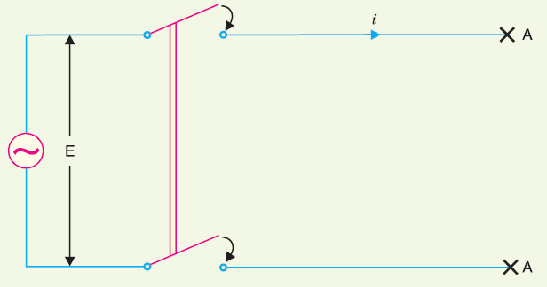

Figure: Case of an open line

When the unloaded line is connected to the voltage source, a voltage wave is set up which travels

along the line. On reaching the terminal point *A*, it is reflected back to the supply end without change of sign. This causes voltage doubling *i.e*. voltage on the line becomes twice the normal value. If E*r.m.s.* is the supply voltage, then instantaneous voltage which the line will have to withstand will be 2 $\sqrt{2}$*E* . This overvoltage is of temporary nature. It is because the line losses attenuate the wave and in a very short time, the line settles down to its normal supply voltage *E*. Similarly, if an unloaded line is switched off, the line will attain a voltage of 2 $\sqrt{2}$*E* for a moment before settling down to the normal value.

**(*b*) Case of a loaded line.** Overvoltages will also be produced during the switching operations of a loaded line. Suppose a loaded line is suddenly interrupted. This will set up a voltage of 2 *Zn i* across the break (*i.e*. switch) where *i* is the instantaneous value of current at the time of opening of line and \**Zn* is the natural impedance of the line.

**(*c*) Current chopping.** Current chopping results in the production of high voltage transients across the contacts of the air blast circuit breaker. It is briefly discussed here. Unlike oil circuit breakers, which are independent for the effectiveness on the magnitude of the current being interrupted, air-blast circuit breakers retain the same extinguishing power irrespective of the magnitude of this current. When breaking low currents (*e.g.* transformer magnetising current) with air-blast breaker, the powerful de-ionising effect of air-blast causes the current to fall abruptly to zero well before the natural current zero is reached. This phenomenon is called current chopping and produces high transient voltage across the breaker contacts. Over voltages due to current chopping are prevented by resistance switching .

**(ii) Insulation failure.** The most common case of insulation failure in a power system is the grounding of conductor (*i.e*. insulation failure between line and earth) which may cause over voltages in the system. This is illustrated in Figure.

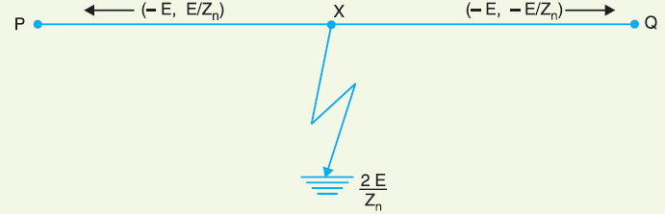

Figure: Insulation failure

Suppose a line at potential *E* is earthed at point *X*. The earthing of the line causes two equal voltages of -*E* to travel along *XQ* and *XP* containing currents -*E*/*Zn* and +*E*/*Zn* respectively. Both

these currents pass through *X* to earth so that current to earth is 2 *E*/*Zn*.

**(iii) Arcing ground.** In the early days of transmission, the neutral of three phase lines was not earthed to gain two advantages. Firstly, in case of line-to-ground fault, the line is not put out of action. Secondly, the zero sequence currents are eliminated, resulting in the decrease of interference with communication lines. Insulated neutrals give no problem with short lines and comparatively low voltages. However, when the lines are long and operate at high voltages, serious problem called *arcing ground* is often witnessed. The arcing ground produces severe oscillations of three to four times the normal voltage.

*The phenomenon of intermittent arc taking place in line-to-ground fault of a 3*-phase *system with consequent production of transients is known as* **arcing ground.**

The transients produced due to arcing ground are cumulative and may cause serious damage to the equipment in the power system by causing breakdown of insulation. Arcing ground can be prevented by earthing the neutral.

**(iv) Resonance.** Resonance in an electrical system occurs when inductive reactance of the circuit becomes equal to capacitive reactance. Under resonance, the impedance of the circuit is equal to resistance of the circuit and the p.f. is unity. Resonance causes high voltages in the electrical system. In the usual transmission lines, the capacitance is very small so that resonance rarely occurs at the fundamental supply frequency. However, if generator *e.m.f*. wave is distorted, the trouble of resonance may occur due to 5th or higher harmonics and in case of underground cables too.

**Phenomena of lightning**

*An electric discharge between cloud and earth, between clouds or between the charge centres of the same cloud is known as* **lightning.**

Lightning is a huge spark and takes place when clouds are charged to such a high potential (+ve or -ve) with respect to earth or a neighbouring cloud that the dielectric strength of neighbouring medium (air) is destroyed. There are several theories which exist to explain how the clouds acquire charge. The most accepted one is that during the uprush of warm moist air from earth, the friction between the air and the tiny particles of water causes the building up of charges. When drops of water are formed, the larger drops become positively charged and the smaller drops become negatively charged. When the drops of water accumulate, they form clouds, and hence cloud may possess either a positive or a negative charge, depending upon the charge of drops of water they contain. The charge on a cloud may become so great that it may discharge to another cloud or to earth and we call this discharge as lightning. The thunder which accompanies lightning is due to the fact that lightning suddenly heats up the air, thereby causing it to expand. The surrounding air pushes the expanded air back and forth causing the wave motion of air which recognize as thunder.

**Mechanism of Lightning Discharge**

Let us now discuss the manner in which a lightning discharge occurs. When a charged cloud passes over the earth, it induces equal and opposite charge on the earth below. Fig.1.4 shows a negatively charged cloud inducing a positive charge on the earth below it. As the charge acquired by the cloud increases, the potential between cloud and earth increases and, therefore, gradient in the air increases. When the potential gradient is sufficient (5 kV*/cm to 10 kV/cm) to break down the surrounding air, the lightning stroke starts.

The stroke mechanism is as under:

**(*i*)** As soon as the air near the cloud breaks down, a streamer called *leader streamer* or *pilot*

*streamer* starts from the cloud towards the earth and carries charge with it as shown in Figure. The leader streamer will continue its journey towards earth as long as the cloud, from which it originates feeds enough charge to it to maintain gradient at the tip of leader streamer above the strength of air. If this gradient is not maintained, the leader streamer stops and the charge is dissipated without the formation of a complete stroke. In other words, the leader streamer will not reach the earth. Figure (*i*) shows the leader streamer being unable to reach the earth as gradient at its end cloud not be maintained above the strength of air. It may be noted that current in the leader streamer is low (<100 A) and its velocity of propagation is about 0·05% that of velocity of light. Moreover, the luminosity of leader is also very low.

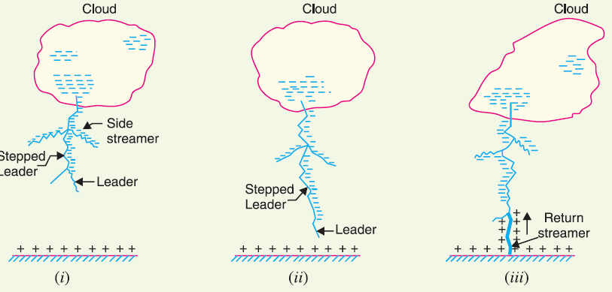

Figure: leader streamer or pilot streamer

**(*ii*)** In many cases, the leader streamer continues its journey towards earth [See Figure (*ii*)] until it makes contact with earth or some object on the earth. As the leader streamer moves towards earth, it is accompanied by points of luminescence which travel in jumps giving rise to stepped leaders. The velocity of stepped leader exceeds one-sixth of that of light and distance travelled in one step is about 50 m. It may be noted that stepped leaders have sufficient luminosity and give rise to first visual phenomenon of discharge.

**(*iii*)** The path of leader streamer is a path of ionisation and, therefore, of complete breakdown of insulation. As the leader streamer reaches near the earth, a *return streamer* shoots up from the earth [See Figure (*iii*)] to the cloud, following the same path as the main channel of the downward leader. The action can be compared with the closing of a switch between the positive and negative terminals; the downward leader having negative charge and return streamer the positive charge. This phenomenon causes a sudden spark which we call lightning. With the resulting neutralisation of much of the negative charge on the cloud, any further discharge from the cloud may have to originate from some other portion of it.

**The following points may be noted about lightning discharge:**

**(*a*)** A lightning discharge which usually appears to the eye as a single flash is in reality made up of a number of separate strokes that travel down the same path. The interval between them varies from 0·0005 to 0·5 second. Each separate stroke starts as a downward leader from the cloud.

**(*b*)** It has been found that 87% of all lightning strokes result from negatively charged clouds and only 13% originate from positively charged clouds.

**(*c*)** It has been estimated that throughout the world, there occur about 100 lightning strokes per

second.

**(*d*)** Lightning discharge may have currents in the range of 10 kA to 90 kA.

**Types of Lightning Strokes**

There are two main ways in which a lightning may strike the power system (*e.g*. overhead lines,

towers, sub-stations etc.), namely; **1.** Direct stroke **2.** Indirect stroke

**1. Direct stroke.** In the direct stroke, the lightning discharge (*i.e.* current path) is directly from the cloud to the subject equipment *e.g*. an overhead line. From the line, the current path may be over the insulators down the pole to the ground. The over voltages set up due to the stroke may be large enough to flashover this path directly to the ground. The direct strokes can be of two types *i.e* (*i*) Stroke *A* and (*ii*) stroke *B*.

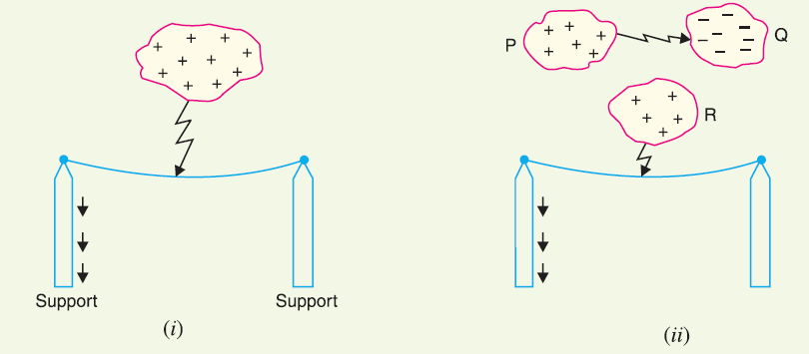

Figure: Direct stroke

**(*i*)** In stroke *A*, the lightning discharge is from the cloud to the subject equipment *i.e*. an overhead

line in this case as shown in above Figure (*i*). The cloud will induce a charge of opposite sign on the tall object (*e.g.* an overhead line in this case). When the potential between the cloud and line exceeds the breakdown value of air, the lightning discharge occurs between the cloud and the line.

**(*ii*)** In stroke *B*, the lightning discharge occurs on the overhead line as a result of stroke *A* between the clouds as shown in above Figure (*ii*). There are three clouds *P*, *Q* and *R* having positive, negative and positive charges respectively. The charge on the cloud *Q* is bound by the cloud *R*. If the cloud *P* shifts too near the cloud *Q*, then lightning discharge will occur between them and charges on both these clouds disappear quickly. The result is that charge on cloud *R* suddenly becomes free and it then discharges rapidly to earth, ignoring tall objects. Two points are worth noting about direct strokes. Firstly, direct strokes on the power system are very rare. Secondly, stroke *A* will always occur on tall objects and hence protection can be provided against it. However, stroke *B* completely ignores the height of the object and can even strike the ground. Therefore, it is not possible to provide protection against stroke *B*.

**2. Indirect stroke.** Indirect strokes result from the electrostatically induced charges on the conductors due to the presence of charged clouds. This is illustrated in Figure. A positively charged cloud is above the line and induces a negative charge on the line by electrostatic induction. This negative charge, however, will be only on that portion of the line right under the cloud and the portions of the line away from it will be positively charged as shown in Figure. The induced positive charge leaks slowly to earth *via* the insulators. When the cloud discharges to earth or to another cloud, the negative charge on the wire is isolated as it cannot flow quickly to earth over the insulators. The result is that negative charge rushes along the line is both directions in the form of travelling waves. It may be worthwhile to mention here that majority of the surges in a transmission line are caused by indirect lightning strokes.

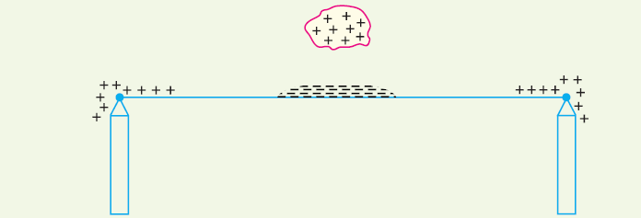

Figure:Indirect stroke

**Harmful Effects of Lightning**

A direct or indirect lightning stroke on a transmission line produces a steep-fronted voltage wave on the line. The voltage of this wave may rise from zero to peak value (perhaps 2000 kV) in about 1 μs and decay to half the peak value in about 5μs. Such a steep-fronted voltage wave will initiate travelling waves along the line in both directions with the velocity dependent upon the *L* and *C* parameters of the line.

**(*i*)** The travelling waves produced due to lightning surges will shatter the insulators and may

even wreck poles.

**(*ii*)** If the travelling waves produced due to lightning hit the windings of a transformer or generator, it may cause considerable damage. The inductance of the windings opposes any sudden passage of electric charge through it. Therefore, the electric charges “piles up” against the transformer (or generator). This induces such an excessive pressure between the windings that insulation may breakdown, resulting in the production of arc. While the normal voltage between the turns is never enough to *start* an arc, once the insulation has broken down and an arc has been started by a momentary overvoltage, the line voltage is usually sufficient to *maintain* the arc long enough to severely damage the machine.

**(*iii*)** If the arc is initiated in any part of the power system by the lightning stroke, this arc will set

up very disturbing oscillations in the line. This may damage other equipment connected to the line.

**Protection against direct strokes & indirect strokes**

Transients or surges on the power system may originate from switching and from other causes but the most important and dangerous surges are those caused by lightning. The lightning surges may cause serious damage to the expensive equipment in the power system (*e.g*. generators, transformers etc.) either by direct strokes on the equipment or by strokes on the transmission lines that reach the equipment as travelling waves. It is necessary to provide protection against both kinds of surges. The most commonly used devices for protection against lightning surges are :

**(*i*)** Earthing screen

**(*ii*)** Overhead ground wires

**(*iii*)** Lightning arresters or surge diverters

Earthing screen provides protection to power stations and sub-stations against direct strokes whereas overhead ground wires protect the transmission lines against direct lightning strokes. However, lightning arresters or surge diverters protect the station apparatus against both direct strokes and the strokes that come into the apparatus as travelling waves. We shall briefly discuss these methods of protection.

**(i) Earthing Screen**

The power stations and sub-stations generally house expensive equipment. These stations can be

protected against direct lightning strokes by providing earthing screen. It consists of a network of

copper conductors (generally called shield or screen) mounted all over the electrical equipment in the sub-station or power station. The shield is properly connected to earth on at least two points through a low impedance. On the occurrence of direct stroke on the station, screen provides a low resistance path by which lightning surges are conducted to ground. In this way, station equipment is protected against damage. The limitation of this method is that it does not provide protection against the travelling waves which may reach the equipment in the station.

**(ii) Overhead Ground Wires**

The most effective method of providing protection to transmission lines against direct lightning strokes is by the use of overhead ground wires as shown in Figure. For simplicity, one ground wire and one line conductor are shown. The ground wires are placed *above* the line conductors at such positions that practically all lightning strokes are intercepted by them (*i.e*. ground wires). The ground wires are grounded at each tower or pole through as low resistance as possible. Due to their proper location, the ground wires will take up all the lightning strokes instead of allowing them to line conductors. When the direct lightning stroke occurs on the transmission line, it will be taken up by the ground wires. The heavy lightning current (10 kA to 50 kA) from the ground wire flows to the ground, thus protecting the line from the harmful effects of lightning. It may be mentioned here that the degree of protection provided by the ground wires depends upon the footing resistance of the tower. Suppose, for example, tower-footing resistance is *R*1 ohms and that the lightning current from tower to ground is *I*1 amperes. Then the tower rises to a potential *Vt* given by ;

*Vt* = *I*1*R*1

Since *Vt* (=*I*1*R*1) is the approximate voltage between tower and line conductor, this is also the voltage that will appear across the string of insulators. If the value of *Vt* is less than that required to cause insulator flashover, no trouble results. On the other hand, if *Vt* is excessive, the insulator

flashover may occur. Since the value of *Vt* depends upon tower-footing resistance *R*1, the value of this resistance must be kept as low as possible to avoid insulator flashover.

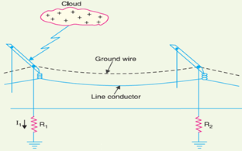

Figure: Direct lightning strokes

***Advantages***

(*i*) It provides considerable protection against direct lightning strokes on transmission lines.

(*ii*) A grounding wire provides damping effect on any disturbance travelling along the line as it

acts as a short-circuited secondary.

(*iii*) It provides a certain amount of electrostatic shielding against external fields. Thus it reduces the voltages induced in the line conductors due to the discharge of a neighbouring cloud.

***Disadvantages***

(*i*) It requires additional cost.

(*ii*) There is a possibility of its breaking and falling across the line conductors, thereby causing a short-circuit fault. This objection has been greatly eliminated by using galvanised stranded steel conductors as ground wires. This provides sufficient strength to the ground wires.

**(iii) Lightning Arresters**

The earthing screen and ground wires can well protect the electrical system against direct lightning strokes but they fail to provide protection against travelling waves which may reach the terminal apparatus. The lightning arresters or surge diverters provide protection against such surges.

*A* **lightning arrester** *or a* **surge diverter** *is a protective device which conducts the high voltage*

*surges on the power system to the ground*

*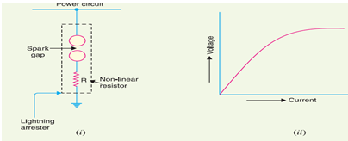.*

Figure: Lightning Arresters

Figure (*i*) shows the basic form of a surge diverter. It consists of a spark gap in series with a non-linear resistor. One end of the diverter is connected to the terminal of the equipment to be protected and the other end is effectively grounded. The length of the gap is so set that normal line voltage is not enough to cause an arc across the gap but a dangerously high voltage will break down the air insulation and form an arc. The property of the non-linear resistance is that its resistance decreases as the voltage (or current) increases and vice-versa. This is clear from the volt/amp characteristic of the resistor shown in Figure (*ii*).

**Action.** The action of the lightning arrester or surge diverter is as under:

(*i*) Under normal operation, the lightning arrester is off the line *i.e.* it conducts no current to earth or the gap is non-conducting.

(*ii*) On the occurrence of overvoltage, the air insulation across the gap breaks down and an arc is formed, providing a low resistance path for the surge to the ground. In this way, the excess charge on the line due to the surge is harmlessly conducted through the arrester to the ground instead of being sent back over the line.

(*iii*)It is worthwhile to mention the function of non-linear resistor in the operation of arrester.

As the gap sparks over due to overvoltage, the arc would be a short-circuit on the power system and may cause power-follow current in the arrester. Since the characteristic of the resistor is to offer high resistance to high voltage (or current), it prevents the effect of a short-circuit. After the surge is over, the resistor offers high resistance to make the gap non-conducting. Two things must be taken care of in the design of a lightning arrester. Firstly, when the surge is over, the arc in gap should cease. If the arc does not go out, the current would continue to flow through the resistor and both resistor and gap may be destroyed. Secondly, *I R* drop (where *I* is the surge current) across the arrester when carrying surge current should not exceed the breakdown strength of the insulation of the equipment to be protected.

**Types of Lightning Arresters**

There are several types of lightning arresters in general use. They differ only in constructional details but operate on the same principle *viz*. providing low resistance path for the surges to the ground. We shall discuss the following types of lightning arresters:

**1.** Rod gap arrester

**2.** Horn gap arrester

**3.** Expulsion type lightning arrester

**4.** Valve type lightning arrester

**Zinc oxide lightning arrester**

**Definition:** The arrester which uses zinc oxide semiconductor as a resistor material, such type of arrester is known as a metal oxide surge arrester or ZnO Diverter. This arrester provides protection against all types of AC and DC over voltages. It is mainly used for [overvoltage protection](https://circuitglobe.com/overvoltage-protection.html) at all voltage levels in a [power system.](https://circuitglobe.com/power-system.html)

## Construction & Working of Metal Oxide Surge Arrester

The zinc oxide is a semiconducting material of N-type. It is pulverised and finely grained. More than ten doping materials are added in the form of fine powders of insulating oxides such as Bismuth (Bi2O3), Antimony Trioxide (Sb2O3), Cobalt Oxide (CoO), Manganese Oxide (MnO2), Chromium oxide (Cr2O3). The powder is treated with some processes, and the mixture is spray dried to obtain a dry powder.

The dry powder is compressed into disc-shaped blocks. The blocks are sintered to obtain a dense poly- crystalline ceramic. The metal oxide resistor disc is coated with a conducting compound to protect the disc from undesirable environmental effect.

[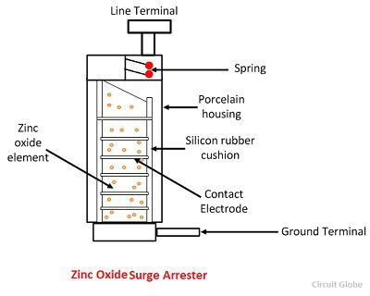](https://circuitglobe.com/wp-content/uploads/2016/09/ZNO-surge-diverter.jpg)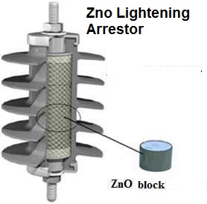

The conducting coating also provides proper contacts and uniform current distribution. The disc then enclosed in a porcelain housing filled with nitrogen gas or SF6 gas. Silicon rubber is used to keep the disc in a position. It also helps in heat transfer from disc to the porcelain housing. The disc is held under pressure using suitable springs.

The ZnO element eliminates series sparks gaps in the diverter. The voltage drop in ZnO diverter takes place at the grain boundaries. There is a potential barrier at the boundary of the each grain of ZnO and this potential barrier control the flow of current from one grain to the next.

At normal voltage, the potential barrier does not allow the current to flow through it. At over voltage the barrier collapse and sharp transition of current from insulating to conducting state take place. The current start flowing and the surge is diverted to ground.

After the travelling of the surge, the voltage across the diverters falls, and the current is reduced to the negligible value of the resistor units, and there is no power follow current.

Figure below shows the values of overvoltage which can be reached without the use of arrester in per units.

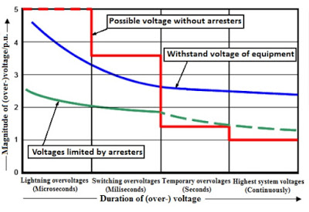 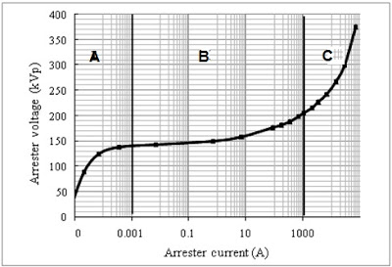

The time axis is divided into the range of lightning overvoltage in microsecond, switching overvoltage in millisecond and temporary overvoltage in second. In the lightning overvoltage and switching overvoltage range, the magnitude of overvoltage can reach several per unit if the system is without arrester protection. Arrester could limit overvoltage below withstand voltage of equipment. This phenomenon clearly shows the importance of arresters for lightning overvoltage protection.

The non linear resistance characteristics of ZnO block can be expressed as shown below,

I/Ir = (V/Vr)x

Where

Ir = Reference Current of Zno block

Vr = Reference Voltage of Zno block

x= Constant the value of x is 30 to 40 in case of Zinc oxide block.

## Advantages of Metal Oxide Surge Arrester

The metal oxide surge arrester has the following merits:

1. It eliminates the risk of spark over and also the risk of shock to the system when the gaps break down.
2. It eliminates the need of voltage grading system.
3. At the normal operating condition, the leakage current in the ZnO is very low as compared to other diverters.
4. There is no power follow current in ZnO diverter.
5. It has high energy absorbing capability.
6. ZnO diverters possess high stability during and after prolonged discharge.
7. In ZnO diverter, it is possible to control the dynamic over voltages in addition to switching surges. This results in economic insulation coordination.

**Surge absorbers**

The travelling waves set up on the transmission lines by the surges may reach the terminals apparatus and cause damage to it. The amount of damage caused not only depends upon the amplitude of the surge but also upon the steepness of its wave front. The steeper the wave front of the surge, the more the damage caused to the equipment. In order to reduce the steepness of the wave front of a surge, we generally use surge absorber.

A **surge absorber** *is a protective device which reduces the steepness of wave front of a surge by absorbing surge energy.*

Although both surge diverter and surge absorber eliminate the surge, the manner in which it is done is different in the two devices. The surge diverter diverts the surge to earth but the surge absorber absorbs the surge energy. A few cases of surge absorption are discussed below:

**(*i*)** A condenser connected between the line and earth can act as a surge absorber. Figure shows how a capacitor acts as surge absorber to protect the transformer winding. Since the reactance of a condenser is inversely proportional to frequency, it will be low at high frequency and high at low frequency. Since the surges are of high frequency, the capacitor acts as a short circuit and passes them directly to earth. However, for power frequency, the reactance of the capacitor is very high and practically no current flows to the ground.

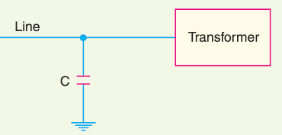

Figure: Capacitor acts as surge absorber to protect the transformer winding

**(*ii*)** Another type of surge absorber consists of a parallel combination of choke and resistance connected in series with the line as shown in Figure. The choke offers high reactance to surge frequencies *(XL* = 2 $π$*f L*). The surges are, therefore, forced to flow through the resistance *R* where they are dissipated.

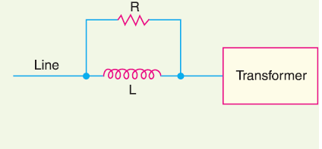

Figure: Parallel combination of choke and resistance connected in series

**(*iii*)** Figure shows another type of surge absorber. It is called Ferranti surge absorber. It consists of an air cored inductor connected in series with the line. The inductor is surrounded by but insulated from an earthed metallic sheet called dissipator. This arrangement is equivalent to a transformer with short-circuited secondary. The inductor forms the primary whereas the dissipator forms the short-circuited secondary. The energy of the surge is used up in the form of heat generated in the dissipator due to transformer action. This type of surge absorber is mainly used for the protection of transformers.

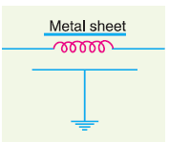

Figure: Another type of surge absorber

**Surge diverters**

A surge arrester is a device to protect electrical equipment from over-voltage transients caused by external (lightning) or internal (switching) events. Also called a surge protection device (SPD) or transient voltage surge suppressor (TVSS), this class of device is used to protect equipment in power transmission and distribution systems. (For consumer equipment protection, different products called surge protectors are used.)

To protect a unit of equipment from transients occurring on an attached conductor, a surge arrester is connected to the conductor just before it enters the equipment. The surge arrester is also connected to ground and functions by routing energy from an over-voltage transient to ground if one occurs, while isolating the conductor from ground at normal operating voltages. This is usually achieved through use of a varistor, which has substantially different resistances at different voltages.

Surge arresters are not generally designed to protect against a direct lightning strike to a conductor, but rather against electrical transients resulting from lightning strikes occurring in the vicinity of the conductor. Lightning which strikes the earth results in ground currents which can pass over buried conductors and induce a transient that propagates outward towards the ends of the conductor. The same kind of induction happens in overhead and above ground conductors which experience the passing energy of an atmospheric EMP caused by the lightening flash. Surge arresters only protect against induced transients characteristic of a lightning discharge's rapid rise-time and will not protect against electrification caused by a direct strike to the conductor. Transients similar to lightning-induced, such as from a high voltage system's fault switching, may also be safely diverted to ground; however, continuous over currents are not protected against by these devices. The energy in a handled transient is substantially less than that of a lightning discharge; however it is still of sufficient quantity to cause equipment damage and often requires protection.

Without very thick insulation, which is generally cost prohibitive, most conductors running more than a minimal distance, say greater than about 50 feet, will experience lightning-induced transients at some time during use. Because the transient is usually initiated at some point between the two ends of the conductor, most applications install a surge arrester just before the conductor lands in each piece of equipment to be protected. Each conductor must be protected, as each will have its own transient induced, and each SPD must provide a pathway to earth to safely divert the transient away from the protected component. The one notable exception where they are not installed at both ends is in high voltage distribution systems. In general, the induced voltage is not sufficient to do damage at the electric generation end of the lines; however, installation at the service entrance to a building is key to protecting downstream products that are not as robust.

## Surge Diverters operation

The event we commonly call a surge is more accurately defined as a high voltage transient or impulse. Surge diverters are designed to divert the impulse away from the sensitive electronic system. That’s why the term diverter is more appropriate – it better describes the function of this device. Surge diverter products commonly use one or more of several electronic components. These include metal oxide varistors (MOVs), silicon avalanche diodes (SADs), and gas tubes. There are differences in how each functions but the intent is the same divert a part of the harmful impulse energy away from the computer or system being protected.

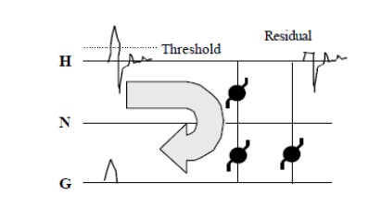

 All surge diverters have a voltage threshold, called a “clamping voltage”, at which they began to conduct. Above that threshold, impulses are shunted across the diverter to another pathway. When the impulse voltage once again falls below the threshold, the diverter stops conducting. Surge diverters also have a “clamping response” time or the time required for the device to respond to an impulse. The amount of energy each is capable of handling without being destroyed is also a consideration. Due to these factors, each type of component used in surge diverters has unique advantages and disadvantages. MOVs have a high clamping voltage (300 to 500 volts) and a slow response time.

This means that in best case scenarios, voltage impulses of less than 500 volts usually enter the computer system unimpeded. In addition, higher voltage events with very fast rise times may pass by the MOV before it is able to respond. And while MOVs can handle a significant amount of energy, they are physically degraded each time they clamp. This characteristic alters their future performance and ultimately leads to physical failure.

These disadvantages have led to the use of the silicon avalanche diode (SAD) either in conjunction with the MOV or in standalone applications. Compared to MOVs, SADs have a faster response time and are not subject to the physical degradation that characterizes MOVs design. The overall energy handling ability of the SAD, however, is not as high, and an impulse that merely degrades and MOV may cause outright destruction of the SAD. To overcome this disadvantage, many surge diverter manufacturers whose designs use standalone SADs will parallel multiple SADs to increase the overall energy handling capability of the protector.

Industry authorities often vigorously debate the effectiveness of this design method. Gas tubes are comparatively slow and have a high clamp voltage. However, they handle almost unlimited amounts of energy. Some surge diverter designs have employed gas tubes as the final line of “brute force” protection to spare the lives of the other surge diverter components in the presence of a catastrophic power line disturbance. In fact, many surge diverter designs incorporate paralleled MOVs, SADs, and/or gas tubes in an effort to improve performance by combining the relative strengths of each particular component.

**Insulation coordination**

**Definition**: Insulation coordination is the process of knowing the insulation levels of the power system components. In other words, it is the process of determining the insulation strength of the equipment. The internal and external insulation of the electrical equipment is exposed to continuous normal voltage and temporary abnormal voltage.

The equipment insulation is designed in such a manner so that it withstands the highest power frequency system voltage, occasional temporary power frequency overvoltage occasional lightning surges. The equipment of power system has assigned the rated insulation level, and their capability can be approved by applying different types of test. The requirement of insulations is determined by considering the following factors.

* Highest Power Frequency System Voltage
* Temporary Power Frequency over voltages
* Transient Overvoltage Surge
* Withstand Levels of the equipment

**Volt-time Curve**

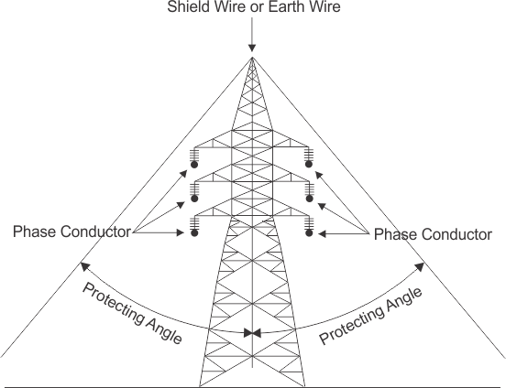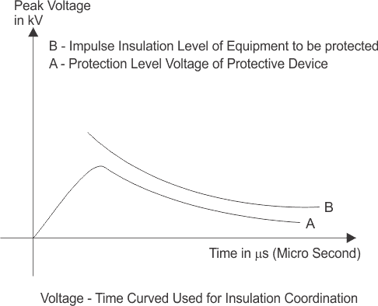

A component of electrical power system may suffer from different level of transient voltage stresses, switching impulse voltage and lightning impulse voltage. The maximum amplitude of transient over voltages reaches the components can be limited by using protecting device like lightning arrestors in the system. Maintaining the insulation level of all the power system component above the protection level of protective device, then ideally there will be no chance of breakdown of insulation of any component. Since the transient over voltage reaches at the insulation after crossing the surge protective devices will have amplitude equals to protection level voltage and protection level voltage impulse insulation level of the components.

**(or)**

The basic insulation level is the reference level expressed in impulse crest voltage with a stranded wave not higher than 1.2/50 μs. The apparatus or equipment should be capable of withstanding test wave above BIL (Basic Insulation Level).

Insulation coordination implies the selection of the insulation of equipment with regards to its application to minimise the undesired incident due to voltage stresses (caused by the overvoltage in the system) within the system. Insulation breakdown means the correlation of the insulation breakdown of the various components of a power system to the insulation of the protective devices used for the protection of that equipment against overvoltage.

[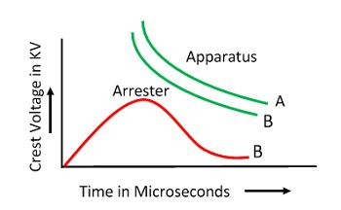](https://circuitglobe.com/wp-content/uploads/2016/09/insulation-coordination.jpg)

For the safe operation of the equipment, it should have equal insulation strength equal to or greater than the basic standard insulation level. The protective equipment for a station substation should be chosen to give the insulation good protection corresponding to the working of these levels as economical as possible.

**Basic impulse insulation levels of different equipments**

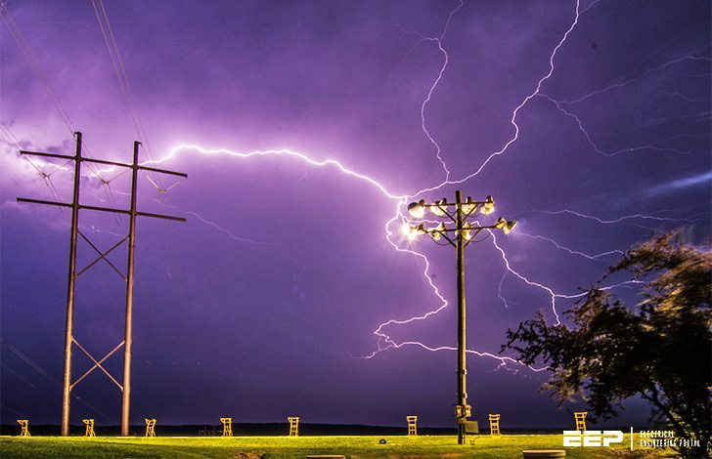

Insulation levels are designed to withstand surge voltages, rather than only normal operating voltages. Since the insulation lines and equipment is protected by surge arresters draining the surges rapidly before the insulation is damaged, the arrester must operate below the minimum insulation level that must withstand the surges.

An example is shown in **Figure** below.

The minimum level is known as the **Basic Insulation Level (BIL)** that must be that of [all of the components of a system](https://electrical-engineering-portal.com/surge-protection-of-electronic-equipment).

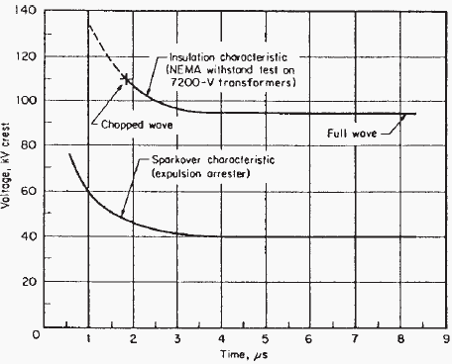

Figure: Insulation coordination

Insulation values above this level for the lines and equipment in the system must be so coordinated that specific protective devices operate satisfactorily below that minimum level.

In the design of lines and equipment considering the minimum level of insulation required, it is necessary to define surge voltage in terms of its peak value and return to lower values in terms of time or duration. Although the peak voltage may be considerably higher than normal voltage, the stress in the insulation may exist for only a very short period of time.

For purposes of design, the [voltage surge](https://electrical-engineering-portal.com/surge-protection-for-frequency-converters) is defined as one that peaks in 1.5 microseconds and falls to one-half that value in 40 microseconds (thousandths of a second).

It is referred to as a **1.5/40 wave**, the steep rising portion is called the wave front and the receding portion the wave tail, **Figure**.

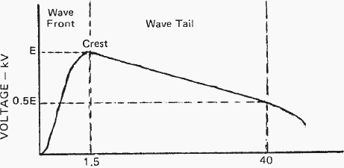

Figure: Surge Voltage 1.5 by 4.0 Wave

Insulation levels recommended for a number of voltage classes are listed in **Table**. As the operating voltages become higher, the effect of a surge voltage becomes less; hence, the ratio of the BIL to the voltage class decreases as the latter increases.

**Table – Typical Basic Insulation Levels**

**Basic insulation level, kV (standard 1.5- × 40-μs wave)**

|  |  |  |
| --- | --- | --- |
| Voltage class, kV | Distribution class | Power class (station, transmission lines) |
| 1.2 | 30 | 45 |
| 2.5 | 45 | 60 |
| 5.0 | 60 | 75 |
| 8.7 | 75 | 95 |
| 15 | 95 | 110 |
| 23 | 110 | 150 |
| 34.5 | 150 | 200 |
| 46 | 200 | 250 |
| 69 | 250 | 350 |

Distribution class BIL is less than that for power class substation and transmission lines as well as consumers’ equipment, so that should a surge result in failure, it will be on the utility’s distribution system where interruptions to consumers are limited and the utility better equipped to handle such failures.

The line and equipment insulation characteristics must be at a higher voltage level than that at which the protecting arrester begins to spark over to ground, and a sufficient voltage difference between the two must exist.

The characteristics of the several type arresters are shown in the curves of **Figure**.

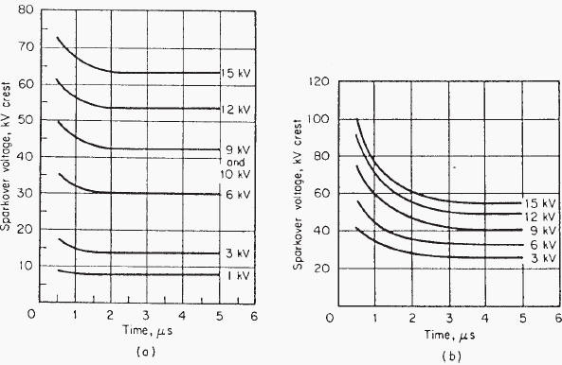Figure: (a) Spark over Characteristics of Distribution Value Arresters; (b) Spark over Characteristics of Expulsion Arresters

The impulse level of lines and equipment must be **high enough for the arresters** to provide protection but low enough to be **economically practical**.

Surges, on occasion, **may damage the insulation of the protective device**; hence, insulation coordination should include that of the protective devices.

As there are a number of protective devices, mentioned earlier, each having characteristics of its own, the characteristics of all of these must be coordinated for proper operation and protection.

Before leaving the subject of insulation coordination, such coordination also applies within a piece of equipment itself. The insulation associated with the several parts of the equipment must not only withstand the normal operating voltage, but also the higher surge voltage that may find its way into the equipment.

So, while the insulation of the several parts is kept nearly equal, that of certain parts is deliberately made lower than others; usually this means the bushing. Since the bushing is usually protected by an air gap or arrester whose insulation under surge is lower than its own, flashover will occur across the bushing and the grounded tank.

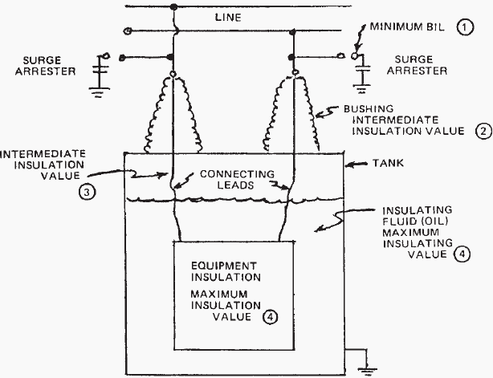

Figure: Simplistic diagram illustrating Basic insulation level (BIL) and Insulation coordination

# What is BIL and how does it apply to transformers?

BIL is an abbreviation for Basic Insulation Level. Insulation levels in electrical equipment are characterized by the withstand voltages used during the impulse test. Impulse test is a dielectric test which consists of the application of a high frequency steep wave front voltage between windings and between windings and ground. The BIL of a transformer is a method used to specify the magnitude of the voltage surge that a transformer can tolerate without any damage to the windings and live parts of the transformer. When lightning impulse over voltage appears in the system, it is discharged through surge protecting device before the transformer gets damaged. BIL rating specifies the minimum voltage that transformer can withstand under this condition.

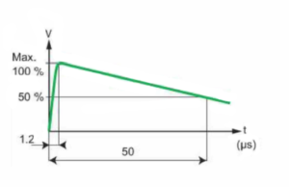

The method of testing of the transformer for BIL has been defined and set by IEEE and ANSI standards. The wave shape has been also defined which is commonly known as 1.2/50 μs voltage wave. The impulse wave shape shows the magnitude of the voltage in KV (Kilo volts), Rise time (tf, time that takes the voltage rise from zero to its peak value in μs (Micro seconds) and duration of the surge (T) sometime referred as Tail time (time that takes the voltage drop to 50% of its peak value in μs (Micro seconds).

This test is done with the initial transformer design to validate the integrity of the insulation and its high frequency surge withstand capability. It is considered one of the design tests for any transformer and needs not to be repeated with every transformer manufactured. However, a quality control impulse test (QC impulse test or production impulse test) is offered as an optional test whenever required. Design impulse test consists of a reduced voltage, 2 chopped wave, and a full voltage impulse applied to the transformer. Voltage and current wave shapes are captured during the above tests for comparison. Any deviation from the reduced wave to full voltage wave shape should be studied. In general, they should be very close to each other. Any new bump in the full wave can be considered as a failure point. Based on the location of the bump, an educated guess can be made as where the failure has occurred. After subjecting the transformer to above voltage surge tests, transformer should pass hi pot test at 60Hz. and double induced voltage test 400 Hz.

During quality control, impulse-only full voltage surge is applied to all of the bushings or the terminals of the transformer before hi pot and double induced test is performed.

Electrical equipment, including wires and cables, are designed to withstand short-term, but very high-voltage pulses such as those sometimes caused by lightning and switching surges. These “spikes,” as they are sometimes called, typically have a rise time in the range of 1.5 microseconds and a fall time around 40 microseconds.

**BIL of Electrical Equipment**

Basic Impulse Level. The basic impulse level (BIL) is the maximum impulse voltage that electrical equipment can withstand without damage. For a cable or wire, it is the maximum impulse voltage that the wire or cable is designed to withstand without damage. Common BIL ratings are for different voltage systems are shown below:

|  |  |
| --- | --- |
| **System Voltage Rating (KV)** | **Basic Impulse Level (KV)** |
| 2.5 | 60 |
| 5.0 | 75 |
| 8.0 | 95 |
| 15.0 | 110 |
| 25.0 | 150 |
| 35.0 | 200 |
| 69.0 | 350 |
| 138.0 | 650 |

**Insulation coordination of transformers, lightning arrester, bus bars and Transmission lines**

Transmission Line Insulation Coordination Involves

* + Shielding angle of the shielding wire
  + Clearance of conductors
  + Selection of the type and length of insulators

Points to remember

* + Shielding Failure Flashover Rate (SFFOR) and Back Flashover Rate (BFR) are two typical design criteria – typical SFFOR is 0.05 f/100kmyr and BFR is 1 f/100km-yr
  + The higher the tower and voltage, the smaller the shielding angle
  + BFR impacts substation insulation requirements
  + Contamination influences creep age distance (mm/kV) and consequently the number of insulator units
  + Generally, from an insulation perspective, transmission line reliability performance is 10% of substation reliability criterion

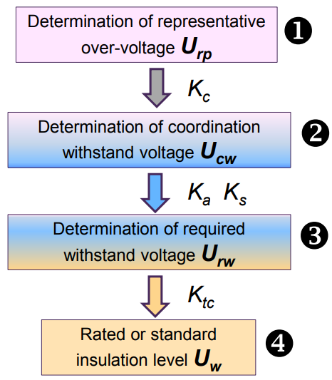**Procedure for Insulation Coordination**

• Transient analysis & simulation

• Origin and level of over-voltages

• Statistical distribution of over-voltages

• Protective level of arresters

• Insulation characteristics

• Determine contamination severity

• Verification of data and assumptions

• Determine coordination factor Kc

• Determine altitude correction factor Ka

• Determine safety factor Ks

• Determine test conversion factor Ktc

• Determine level and range of Uw

(for both internal and external)

*******